About Your Adventure Works Cycles Bicycle
Congratulations! You've purchased a high quality bicycle that will give you years of riding enjoyment. This owner’s manual is made for several different bicycles. Some of the illustrations may not look exactly like the parts of the bicycle, but the instructions are correct. If the bicycle has any parts that are not described in this manual, look for separate Special Instructions that are supplied with the bicycle.
NOTE: All of the directions (right, left, front, rear, etc.) in this manual are as seen by the rider while seated on the bicycle.
Attach and use only Adventure Works Cycles brand accessories and replacement parts on the bicycle. You'll need these tools when servicing your Adventure Works Cycles bicycle.
Small Adjustable Wrench Large Adjustable Wrench
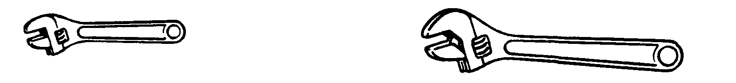
(Jaws must open at least 9/16 inch.) (Jaws must open at least 1 1/4 inch.)
Flat-blade Screwdriver Phillips Screwdriver
Slip-Joint Pliers Metric Allen Wrenches
(Needed on some models.)
